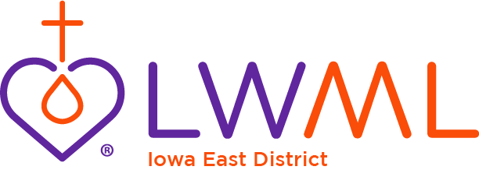
2026-2028 IED Mites
LWML IED Mission Grants:
Mission Central—Support of New LCMS Missionaries $5,000
Camp Io-Dis-E-Ca—Expansion of the Horse Program $7,500
Ft. Wayne Seminary Food Bank—Purchase Fresh Food & Produce for Seminary Students $5,000
St. Silas, North Liberty—For Updating Office Equipment $5,000
Ft. Wayne Seminary Coop—Renovate and Buy New Cooler/Freezer $5,000
Dakota Boys and Girls Ranch—Providing Physical & Mental Wellness for At-Risk Children $4,000
Higher Things—Providing Lutheran Curriculum Report $5,000
Lutheran Heritage Foundation (LHF)—God’s Word for the Persecuted in China $6,500
Lutheran Bible Translators—Changed Lives, Shared Word: Restoring the Bible Printing Fund $5,000
Lutherans For Life—“For Life” Ministry Development $7,500
Concordia, St. Louis—LOGOS Bible Software $6,000
Lutheran Home for the Aged Association East—Chapel Advancement $7,500
MOST Ministries—Training Servant Leaders for Mission $1,000
2026-2028 LWML IED Mission Grants = $70,000
2026-2028 LWML IED Scholarships = $30,000
Grand Total IED Mites = $100,000

2026-2028 IED Mites

LWML IED Mission Grants:
Mission Central—Support of New LCMS Missionaries $5,000
Camp Io-Dis-E-Ca—Expansion of the Horse Program $7,500
Ft. Wayne Seminary Food Bank—Purchase Fresh Food & Produce for Seminary Students $5,000
St. Silas, North Liberty—For Updating Office Equipment $5,000
Ft. Wayne Seminary Coop—Renovate and Buy New Cooler/Freezer $5,000
Dakota Boys and Girls Ranch—Providing Physical & Mental Wellness for At-Risk Children $4,000
Higher Things—Providing Lutheran Curriculum Report $5,000
Lutheran Heritage Foundation (LHF)—God’s Word for the Persecuted in China $6,500
Lutheran Bible Translators—Changed Lives, Shared Word: Restoring the Bible Printing Fund $5,000
Lutherans For Life—“For Life” Ministry Development $7,500
Concordia, St. Louis—LOGOS Bible Software $6,000
Lutheran Home for the Aged Association East—Chapel Advancement $7,500
MOST Ministries—Training Servant Leaders for Mission $1,000
2026-2028 LWML IED Mission Grants = $70,000
2026-2028 LWML IED Scholarships = $30,000
Grand Total IED Mites = $100,000

